Name: M.VINAY
Roll No: 23BQ1A4951
PBL ID:DB_262790141
Date: 14-07-2026
Topic: Introduction to SQL (using single row functions to customize the output)

1. Display the current date, label the column Date.
Ans
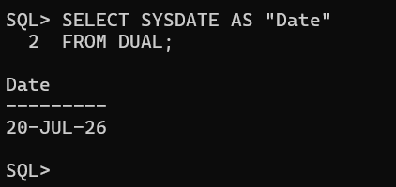
2. Employee number, last name, salary, and salary increased by 15.5% (whole number), label New Salary.
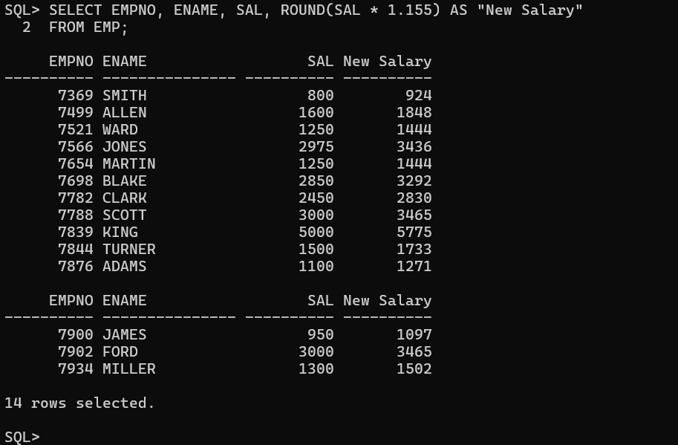

3. Add a column alias that subtracts old salary from new salary, label Increase.
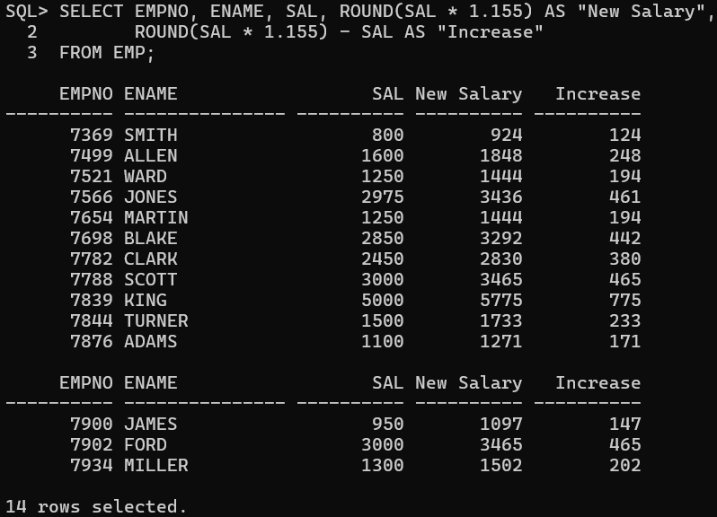
4. Ename (first letter uppercase, rest lowercase) and length of ename, for names starting with J, A, or M, sorted by ename.
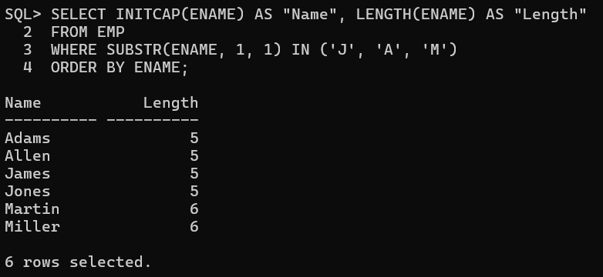
5. Prompt for a letter, show employees whose last name starts with that letter.
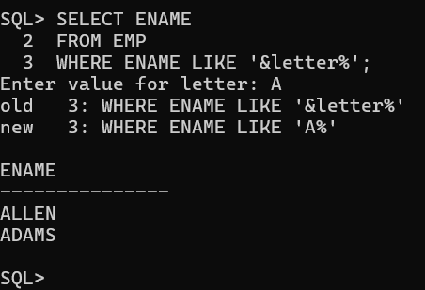
6. Ename and months worked between today and hire date, label MONTHS_WORKED, sorted, rounded up.
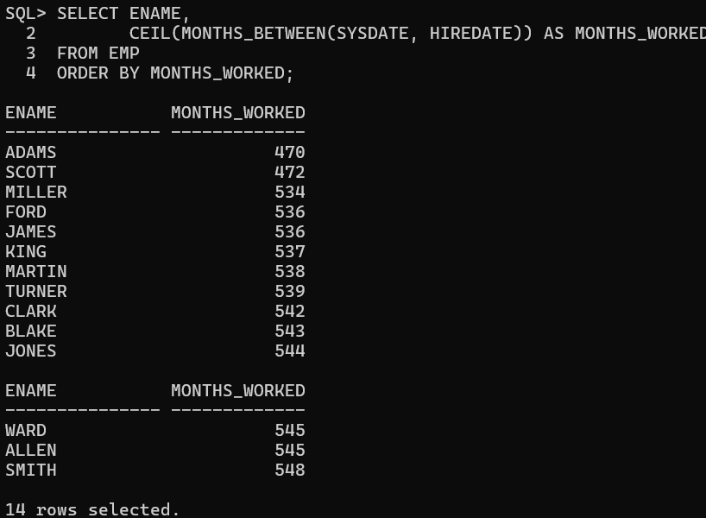
7. Report: "<ename> earns <sal> monthly but wants <3 times salary>", label Dream Salaries.
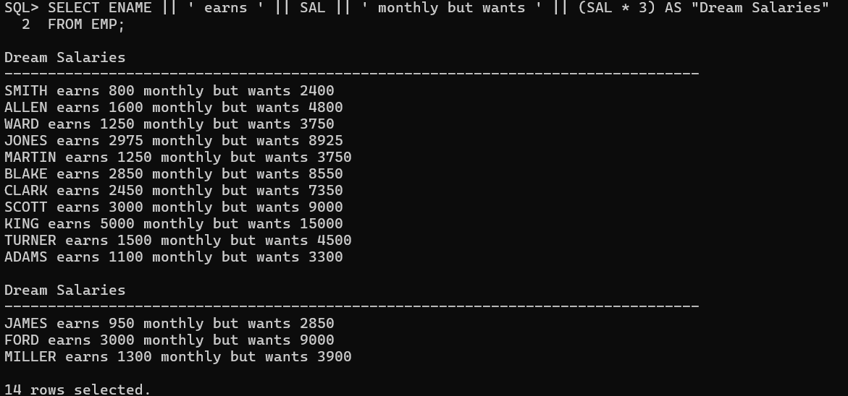

8. Last name and salary, salary formatted 15 characters, left-padded with $, label SALARY.
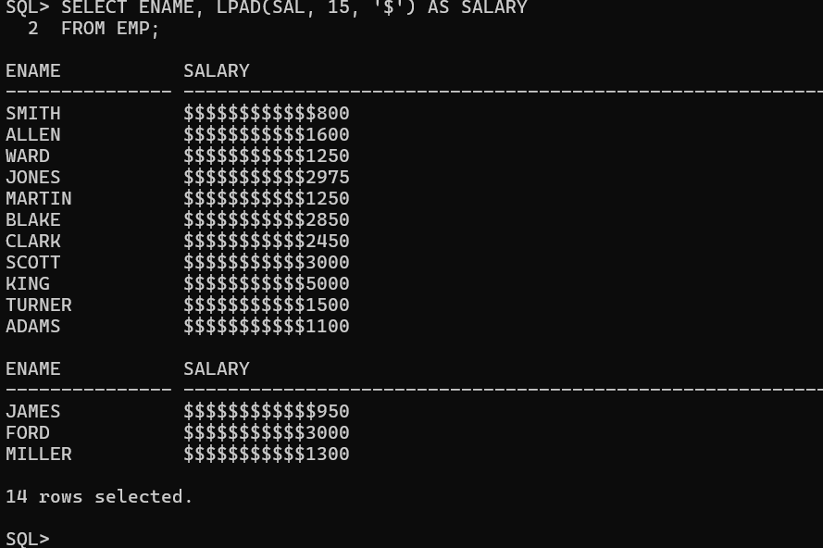
9. Last name, hire date, review date (first Monday after 6 months of service), label REVIEW, formatted like "Monday, the Thirty-First of July, 2000."
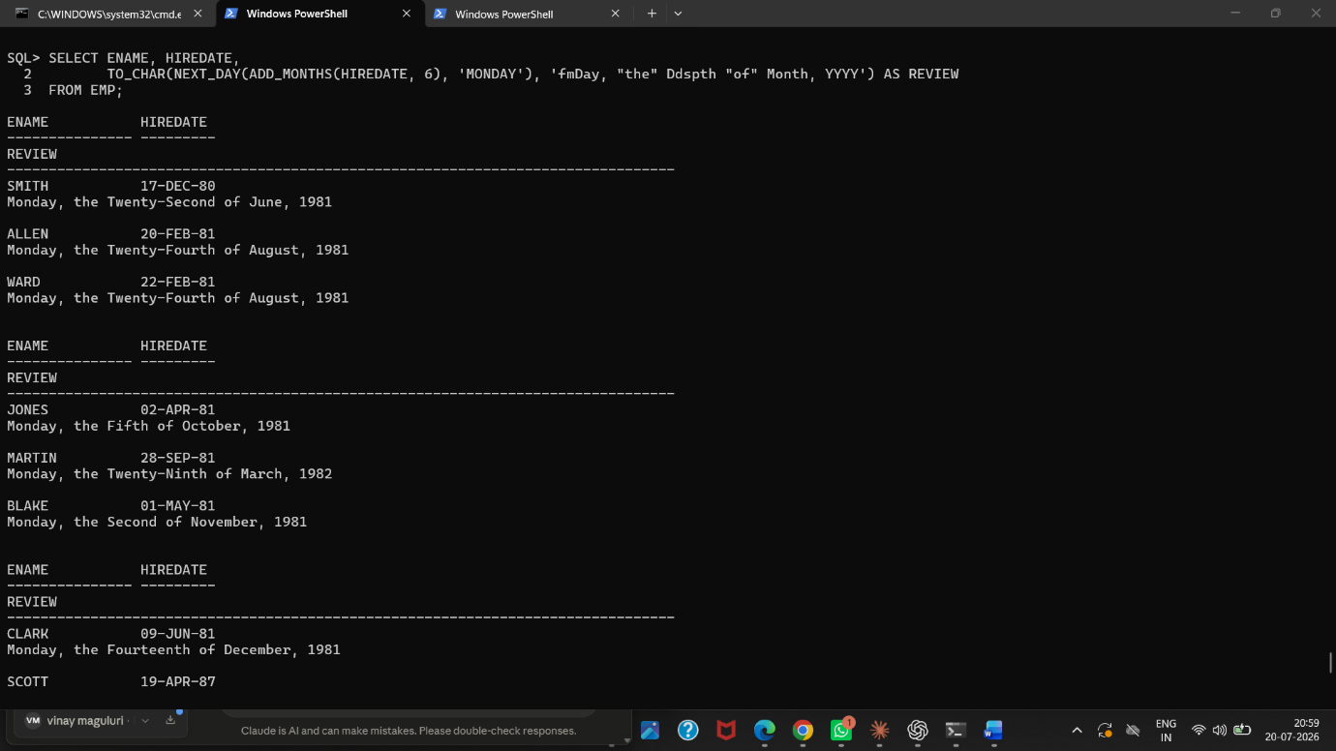
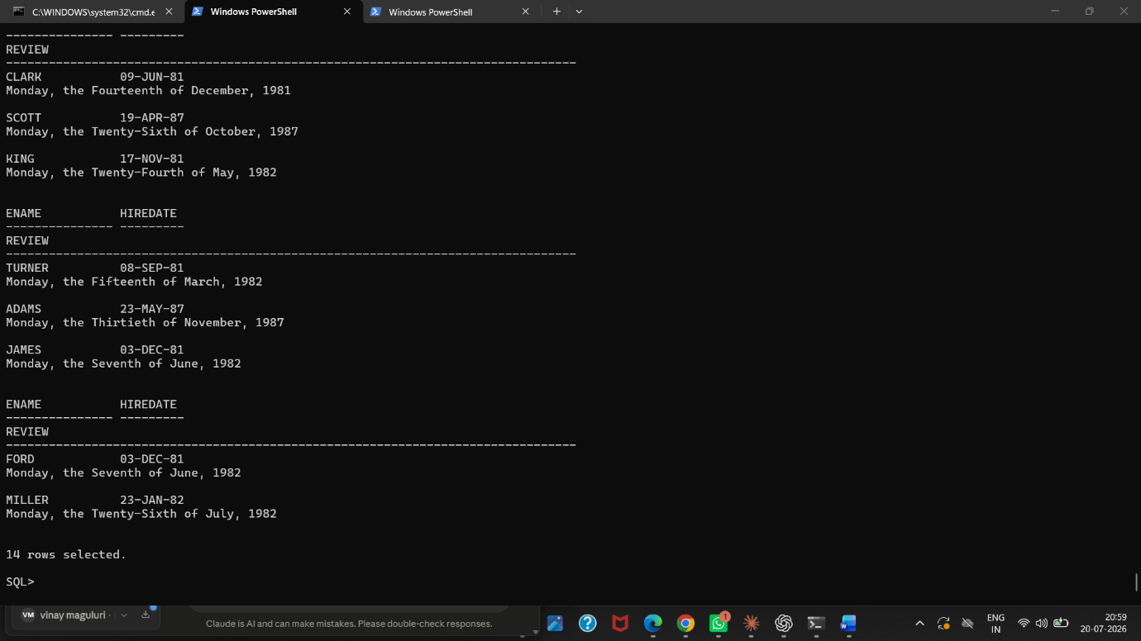
10. Last name, hire date, and day of week hired, label DAY, ordered by day of week starting Monday.
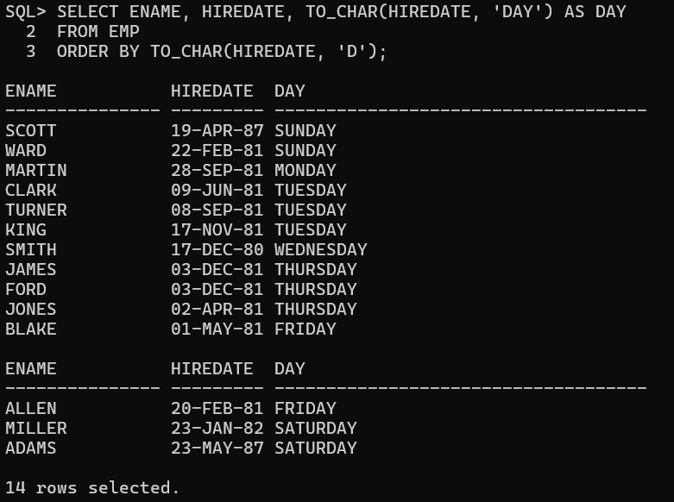

11. Last names and commission amounts; if no commission, show "No Commission", label COMM.
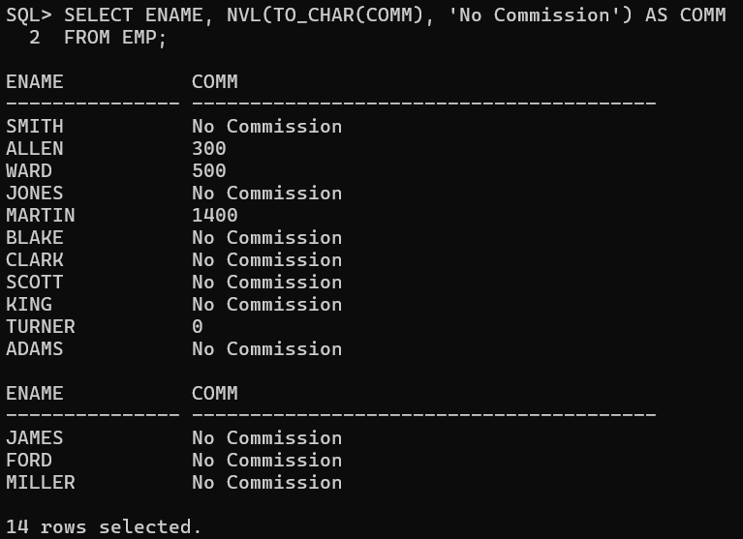
12. First eight characters of last name, salary shown as asterisks (1 asterisk = $1000), sorted descending by salary, label EMPLOYEES_AND_THEIR_SALARIES.

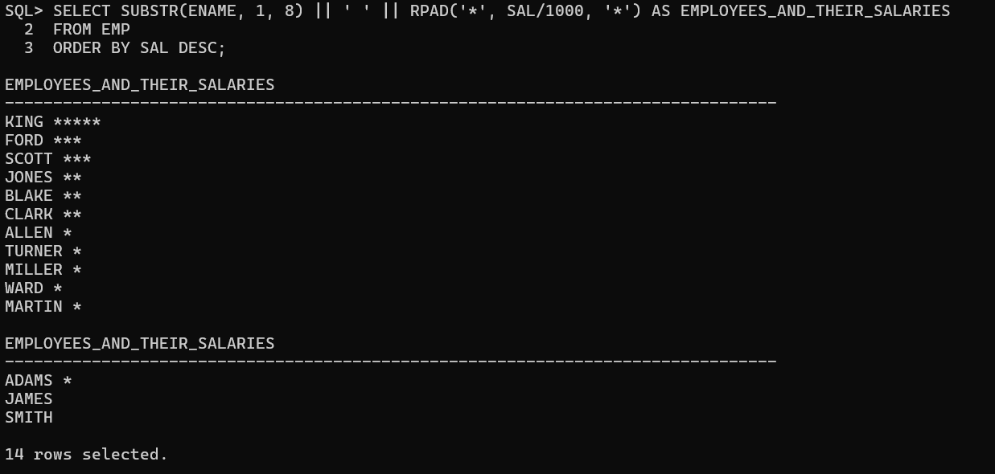
13. Using DECODE, display grade based on JOB_ID: PRESIDENT-A, MANAGER-B, SALESMAN-C, CLERK-D.
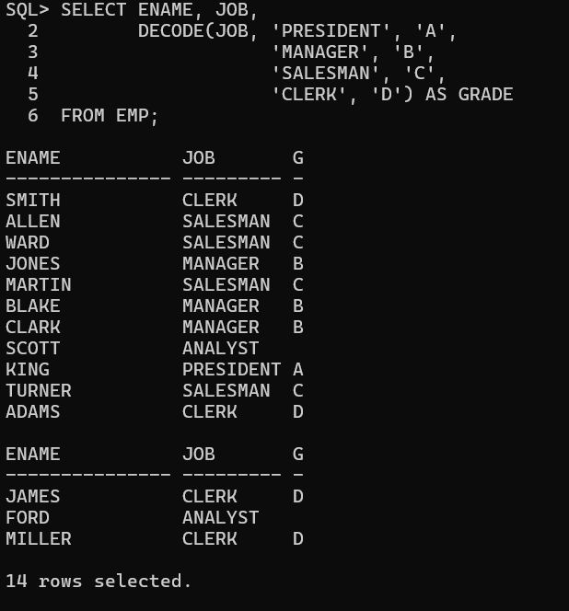
14. Rewrite Q13 using CASE syntax.
